**DATABASE MANAGEMENT SYSTEM PRACTICAL**

**AMAN**

**BCA1 M2**

**08913702021**

**SET - A**

**Ans1. Creating tables:**

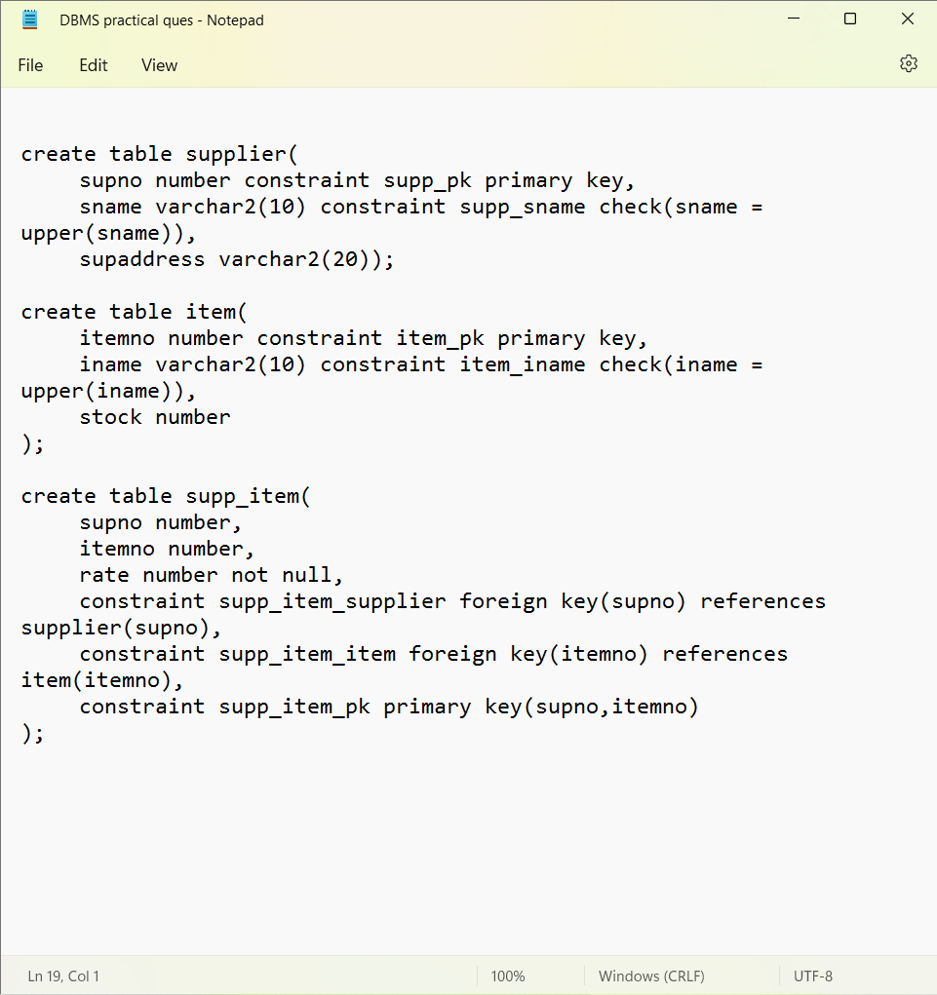

**Output:**

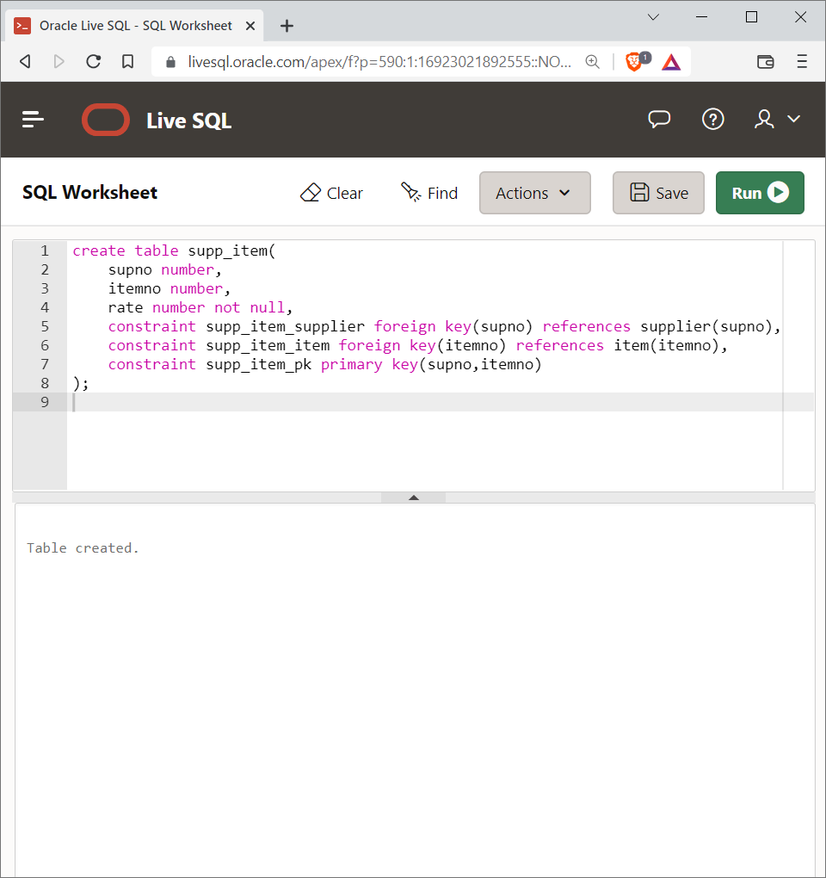

**Table – Item:**



**Output:**



**Table – supp_item:**



**Output:**



**Queries on the table:**

**Query-1:**

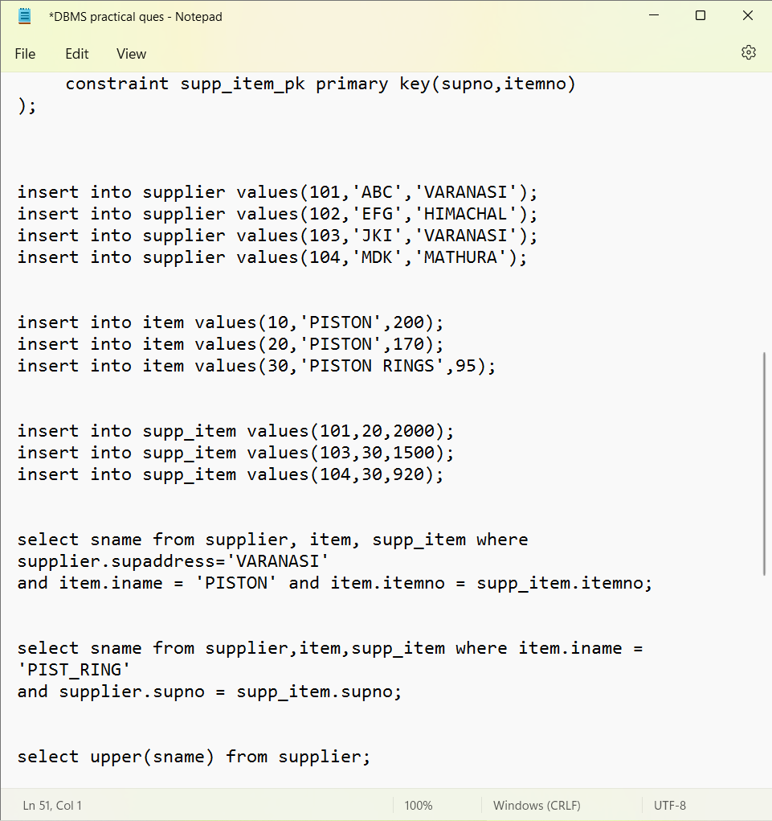

**Output:**

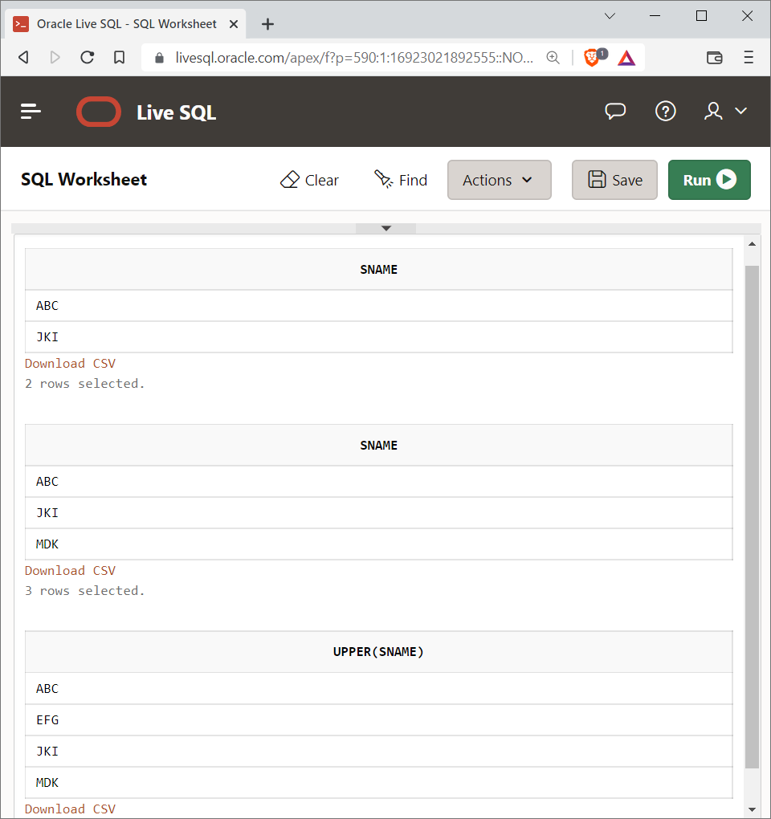

**Query – 2:**



**Output:**



**Query – 3:**



**Output:**



**Ans 2.**

1. **Creating a table:**

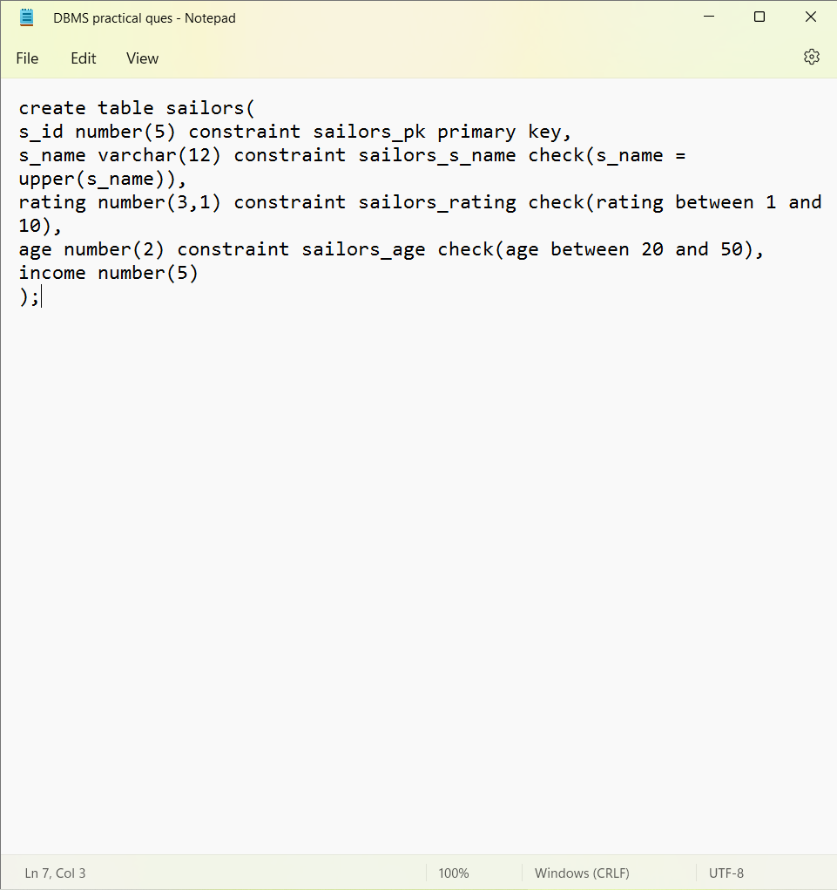

**Output:**

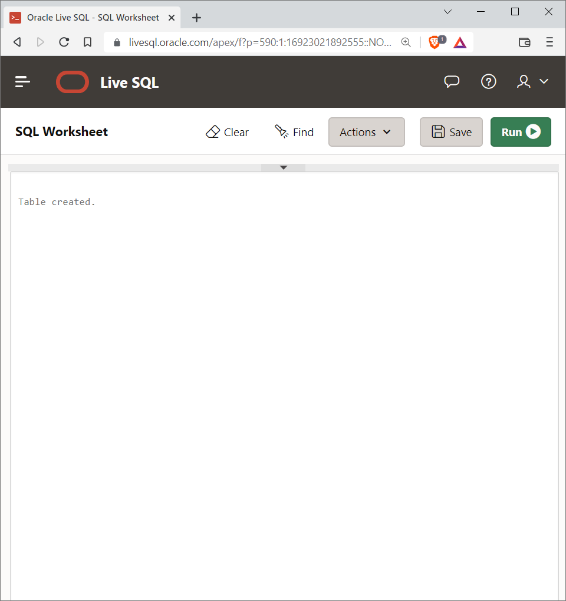

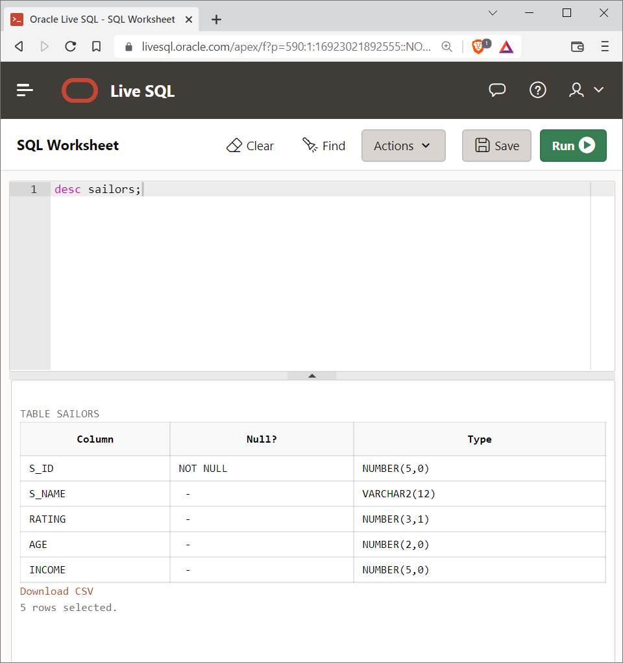

1. **Altering the table:**

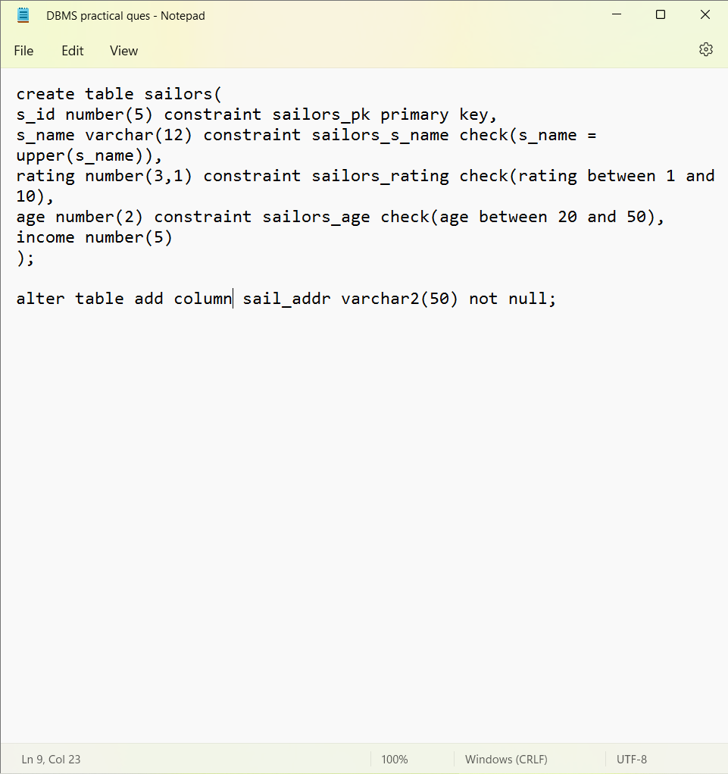

**Output:**

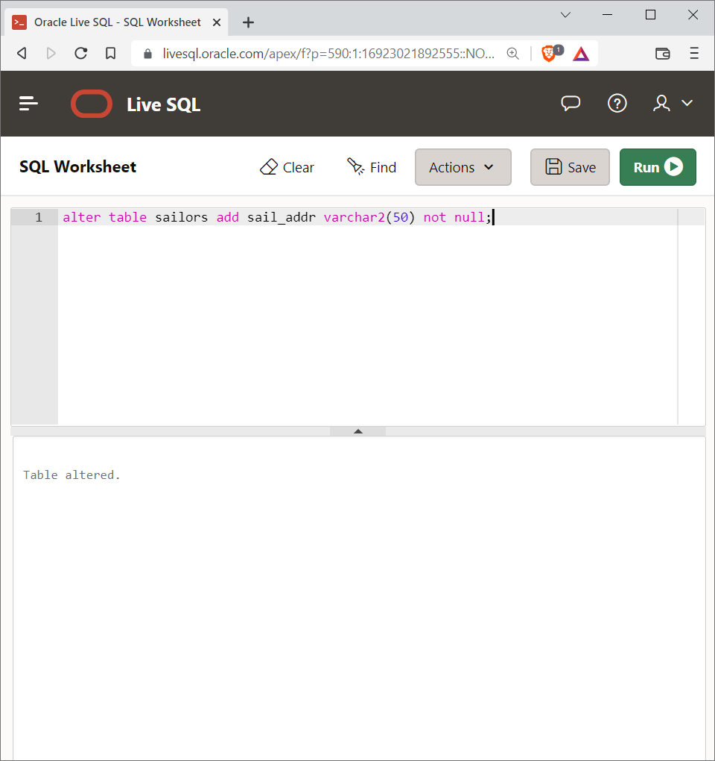

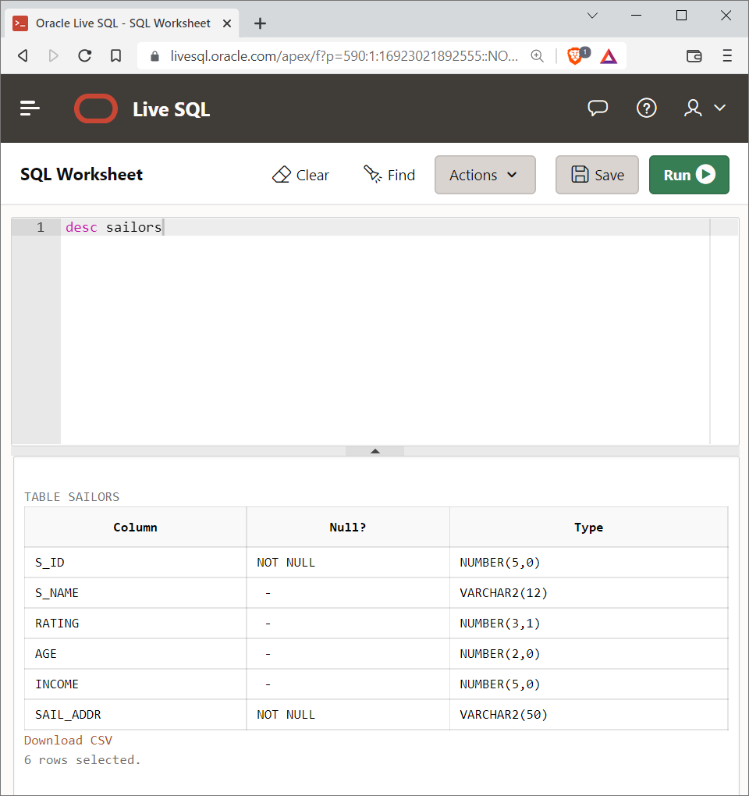

1. **Dropping table:**

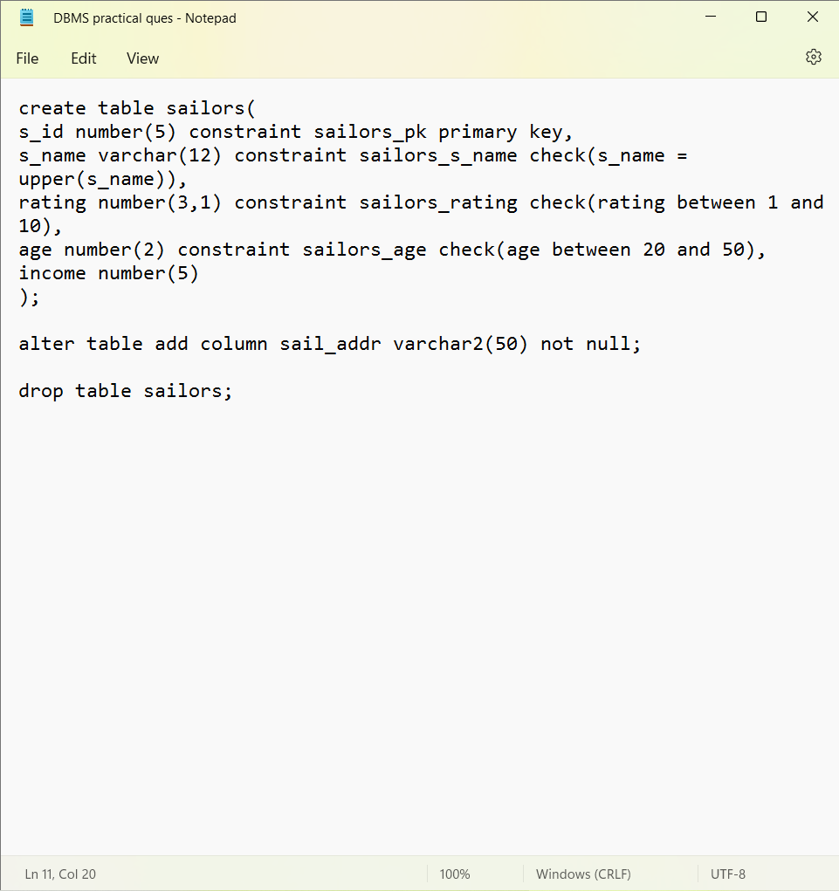

**Output:**

